12210102 MAK KIT TIN

15208249 LEUNG KAI HIN

13205633 CHAN WING SUM

13207296 Yeung Man Kit

system design nd testing – phrase 4

group 10 – 404 not found

design

# System Design

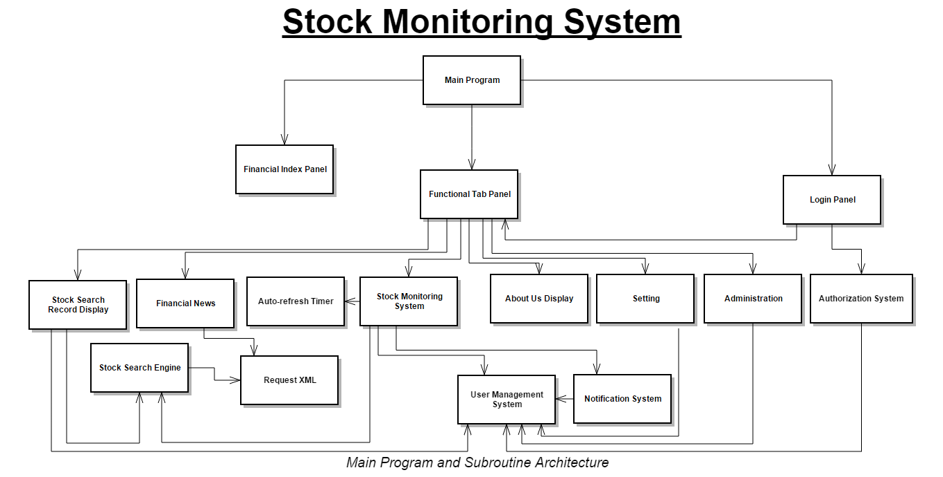

# Component Design

## Login Panel

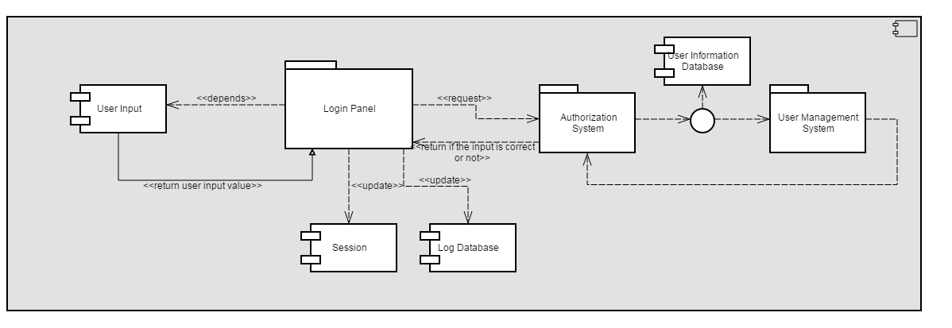

## Stock Search

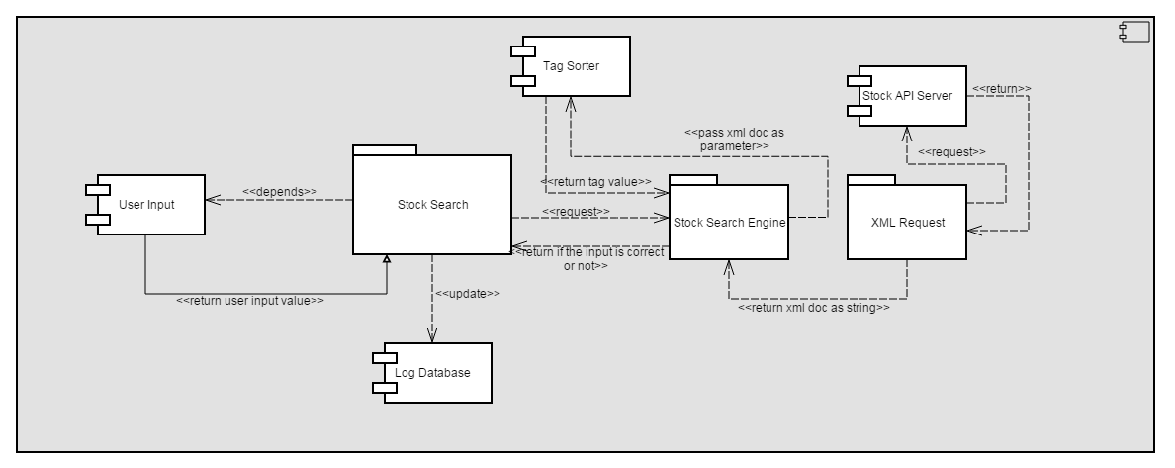

## Financial News

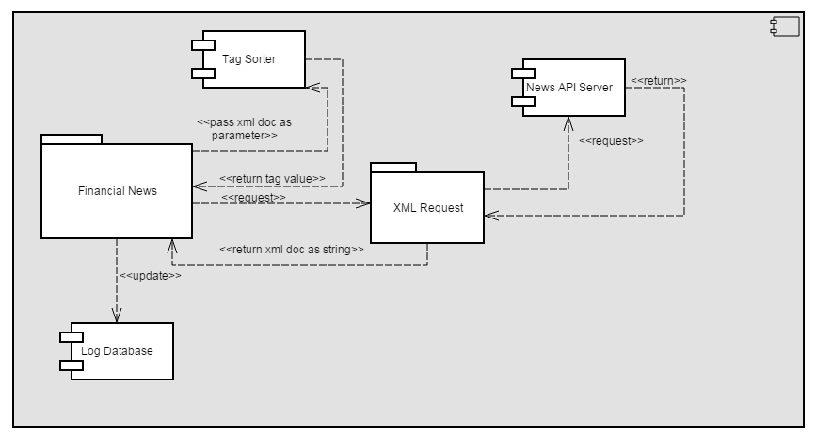

## About Us

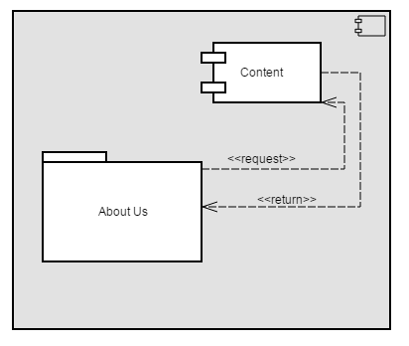

## Financial Index Panel

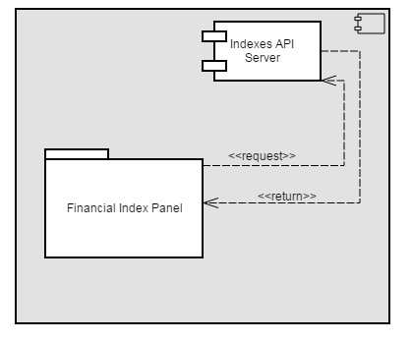

## Setting

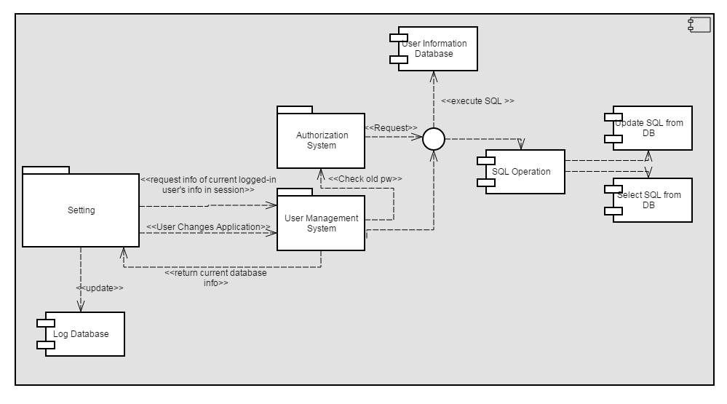

## Stock Monitoring System

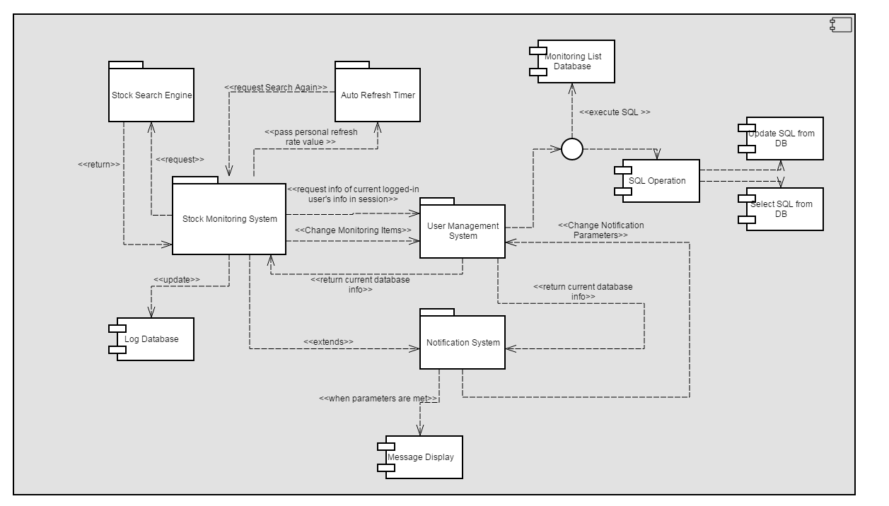

## Administration

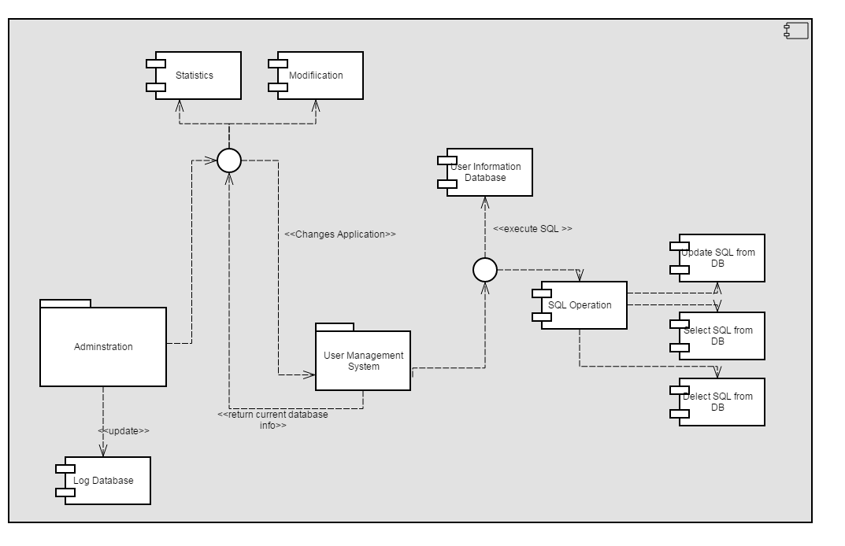

testing

# Black-box Unit Testing

## Stock Search Test (15208249 LEUNG KAI HIN)

### FLOW GRAPH:

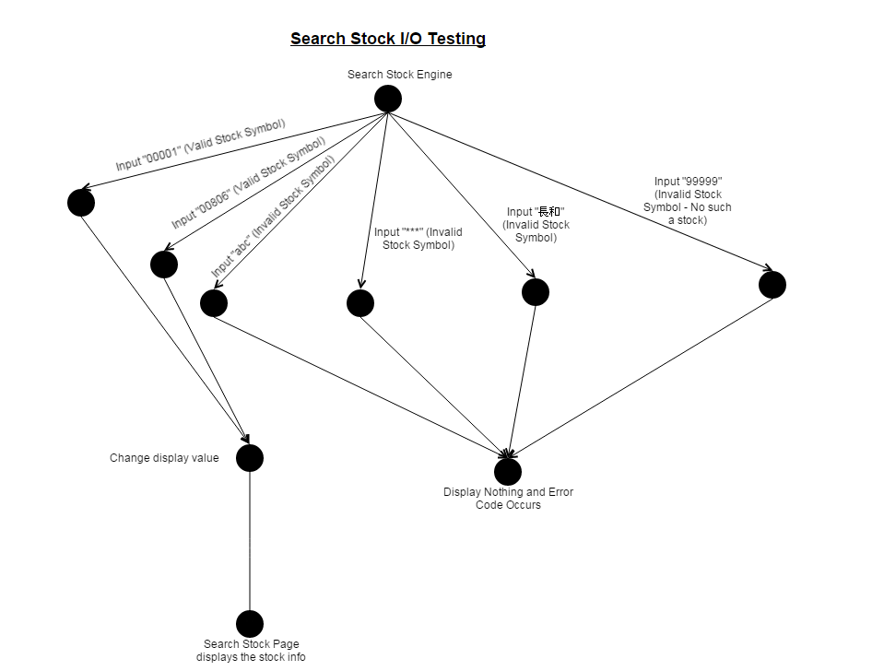

|  |  |
| --- | --- |
| Path 1 | |
| Test Case | Input “00001” to search |
| Log | Change display value then Display on UI |

|  |  |
| --- | --- |
| Path 2 | |
| Test Case | Input “00806” to search |
| Log | Change display value then Display on UI |

|  |  |
| --- | --- |
| Path 3 | |
| Test Case | Input “abc” to search |
| Log | Display Nothing and Error Code Occurs |

|  |  |
| --- | --- |
| Path 4 | |
| Test Case | Input “***” to search |
| Log | Display Nothing and Error Code Occurs |

|  |  |
| --- | --- |
| Path 5 | |
| Test Case | Input “長和” to search |
| Log | Display Nothing and Error Code Occurs |

|  |  |
| --- | --- |
| Path 6 | |
| Test Case | Input “99999” to search |
| Log | Display Nothing and Error Code Occurs |

### Input “00001” to search

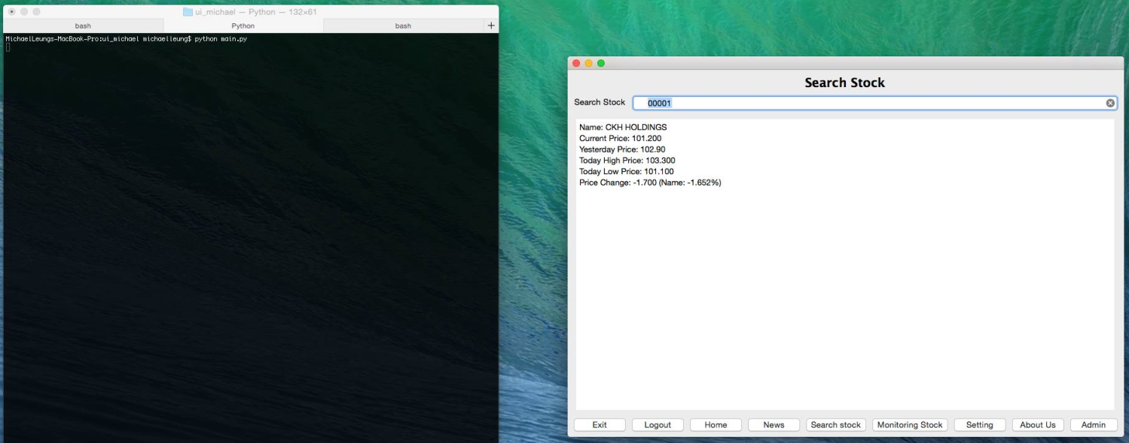

### input “00806” to search

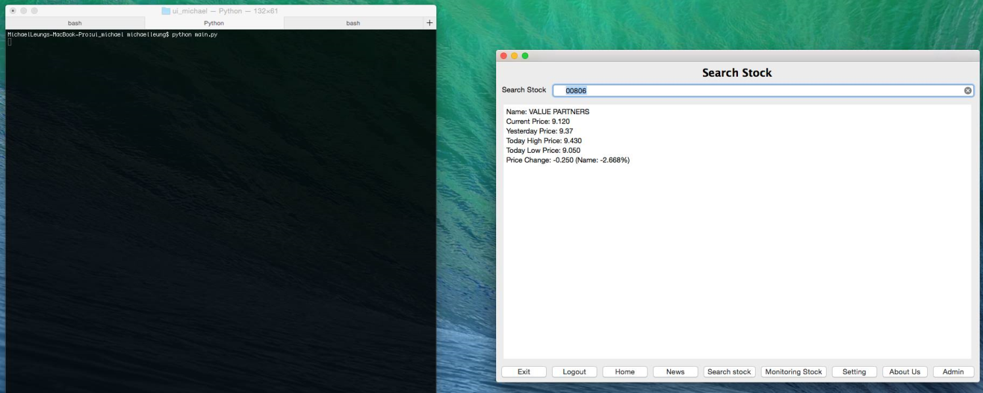

### input “abc” to search

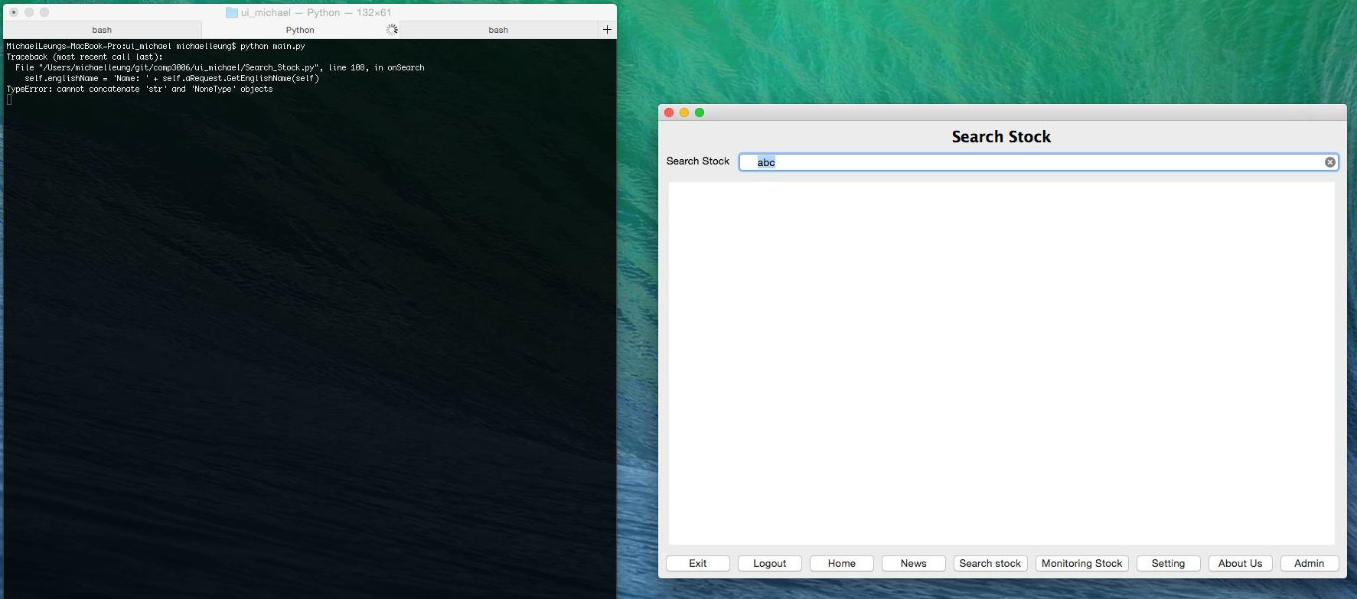

### input “***” to search

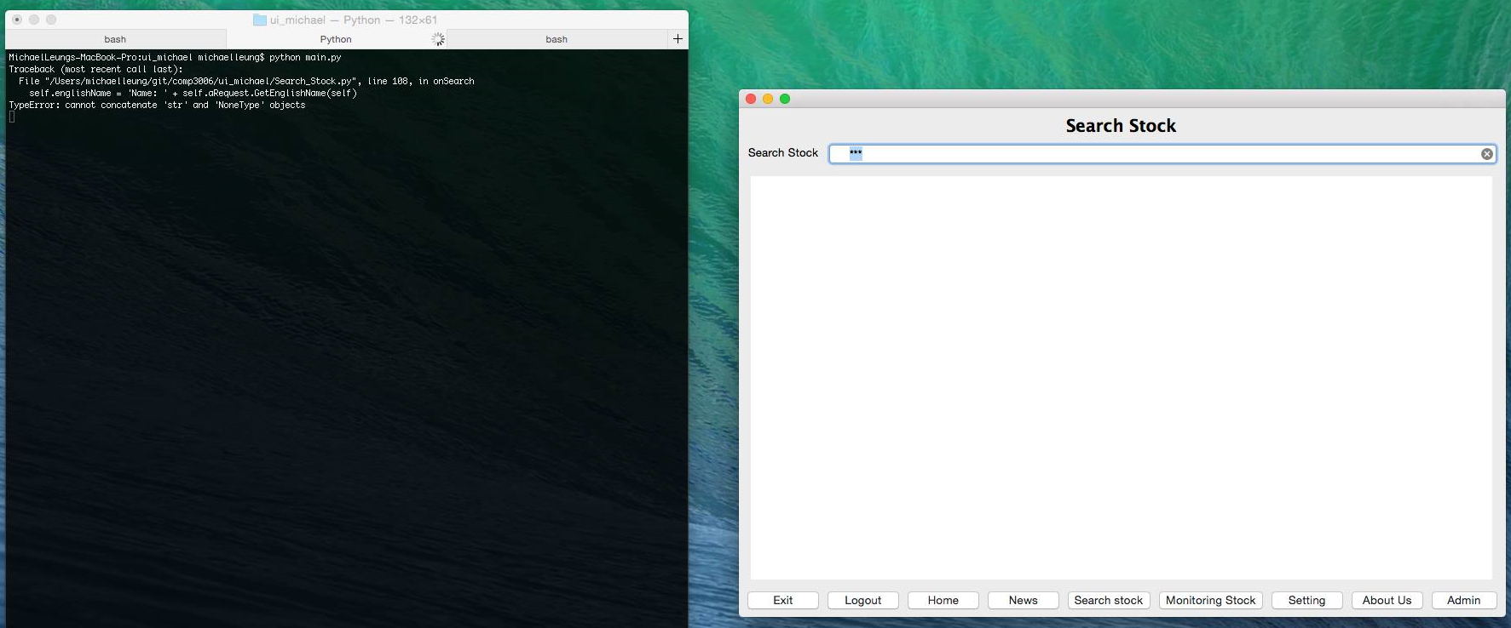

### input “長和” to search

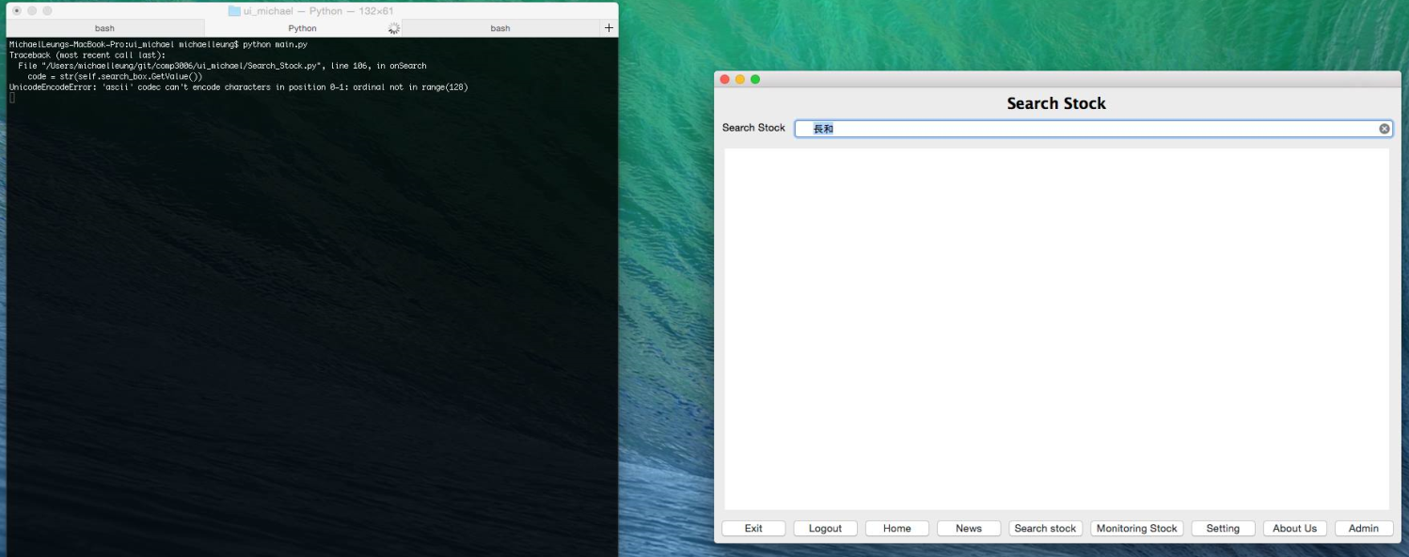

### input “99999” to search

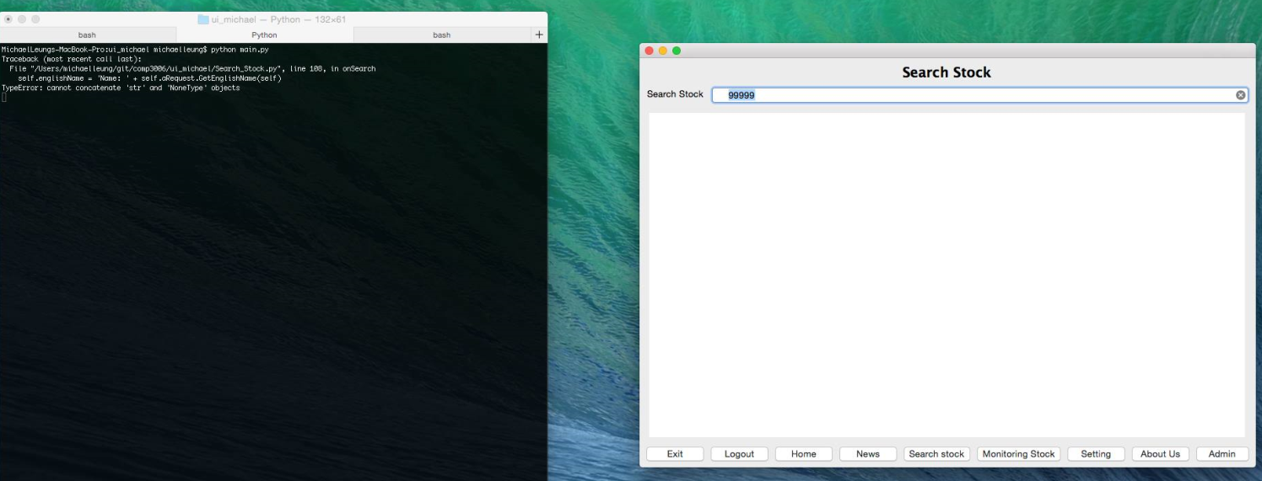

## XML Request (12210102 MAK KIT TIN)

### flow graph:

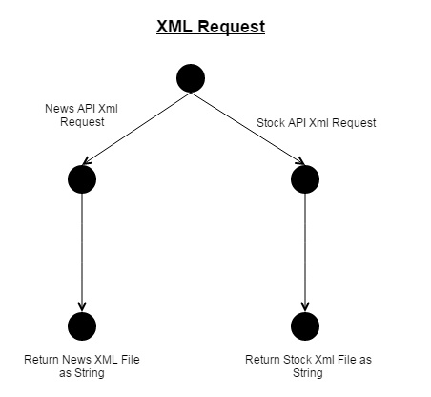

### request xml link = “” (STOCK API)

#### Code:

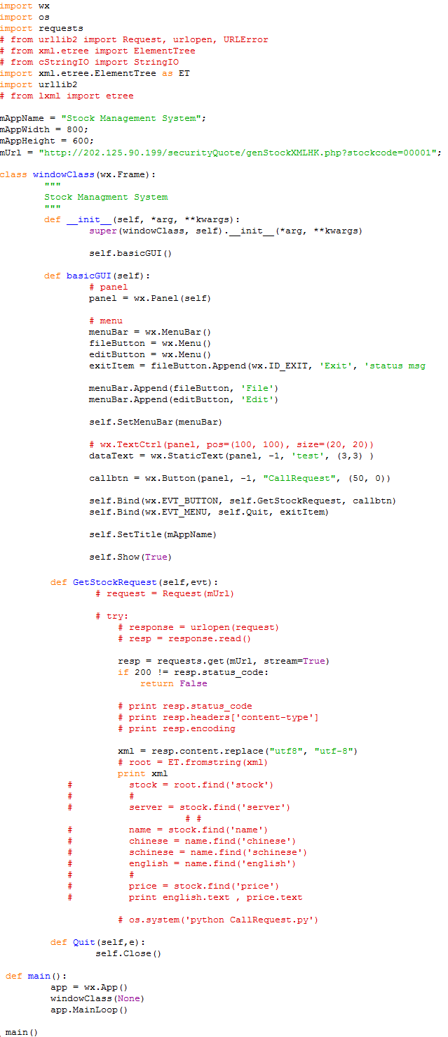

#### Return Value:

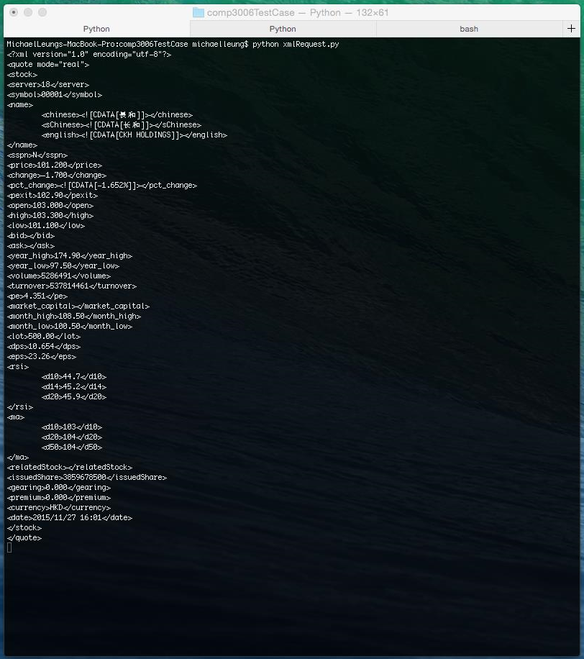

### REQUEST XML LINK = “” (NEWS API)

#### Code:

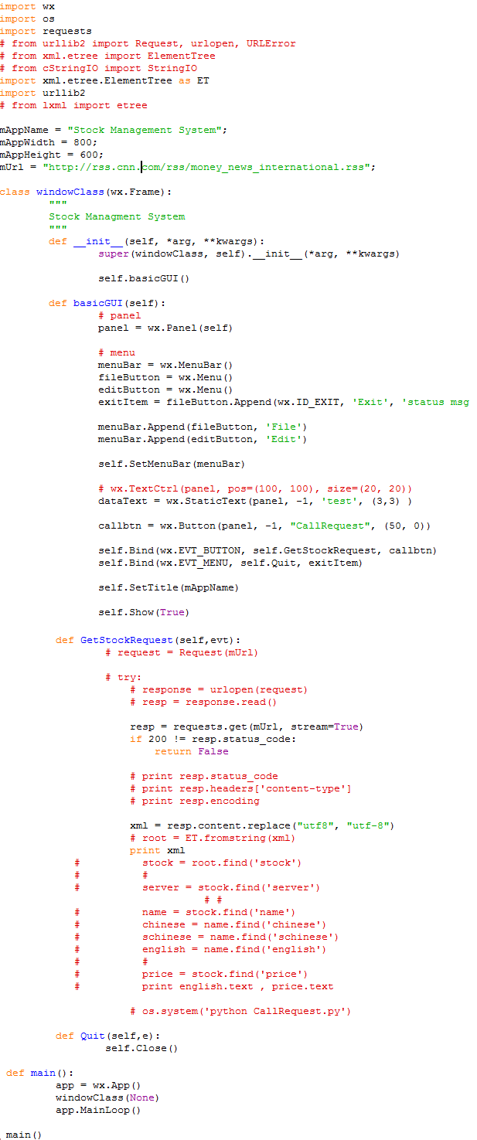

#### Return Value:

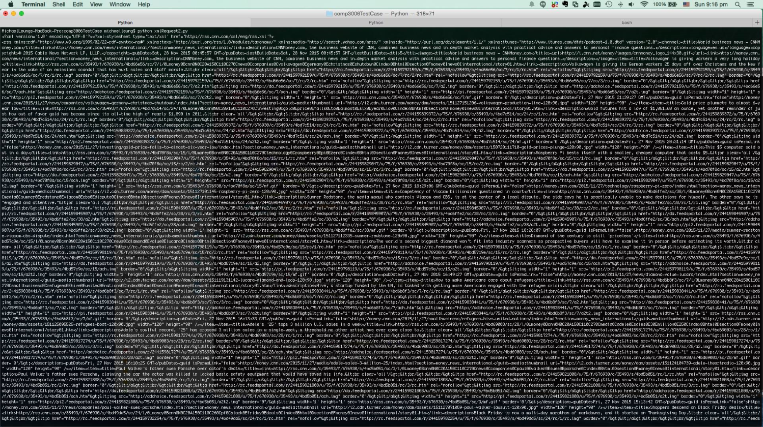

## FRAME SWITCH (YEUNG MAN KIT 13207296)

As a customer, we can login through the login system. After verifying the user identity, user can go to different pages by using the button of bottom. Through the testing, we discover that there is no error for frame change. (Picture 1.1 and 1.2)



1.1Button of frame

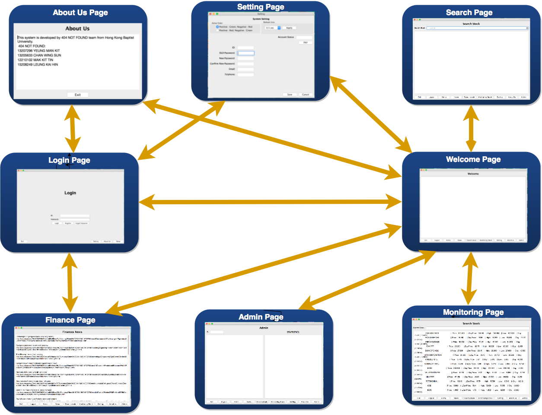

1.2How user access the system with frame change

## Change_PW_ctrl Testing (Chan Wing Sum 13205633)

|  |  |  |  |
| --- | --- | --- | --- |
| **Test case Id** | **Test case Description** | **Expected Result** | **Actual Result** |
| 1 | Precondition: Run Setting  Old password = “1234e6”  Enter:  Old password: “1234e6”  New password: “234567”  Confirm password: “234567”  Button: “Save” | Password change successfully | PASS |
| 2 | Precondition: Run Setting  Old password = “1234e6”  Enter:  Old password: “1234e6”  New password: “234567”  Confirm password: “345678”  Button: “Save” | Password cannot be change, Now password and confirm password must be match. | PASS |
| 3 | Precondition: Run Setting  Old password = “123456”  Enter:  Old password: “234567”  New password: “234567”  Confirm password: “234567”  Button: “Save” | Password cannot be change, Old password must be valid. | PASS |

In this unit, the text controllers is focused to input only character and integer, the only thing need to consider is the input is as same as database. As a result, I choose three test-cases for testing: First one with valid current password and the confirm password is match with new password. Second one is with valid current password but the confirm password isn’t match with new password. Third case is with invalid current password.

# White-box Unit Testing

## Financial News Request Testing (12210102 MAK KIT TIN)

### Flow graph:

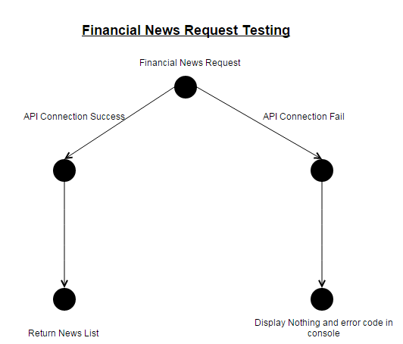

|  |  |
| --- | --- |
| Path 1 | |
| Test Case | News Feed API Connection Success |
| Log | News List Display |

|  |  |
| --- | --- |
| Path 2 | |
| Test Case | News Feed API Connection Failed |
| Log | UI Display Nothing & Error Code Occurs in Console |

### news api Connection Success Test:

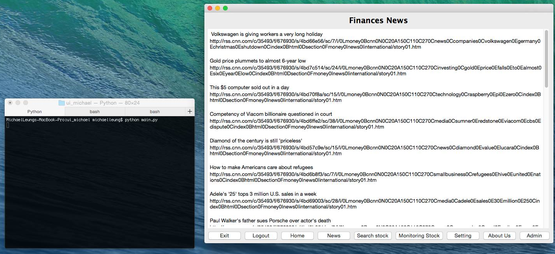

### news api Connection Fail Test (Wi-Fi):

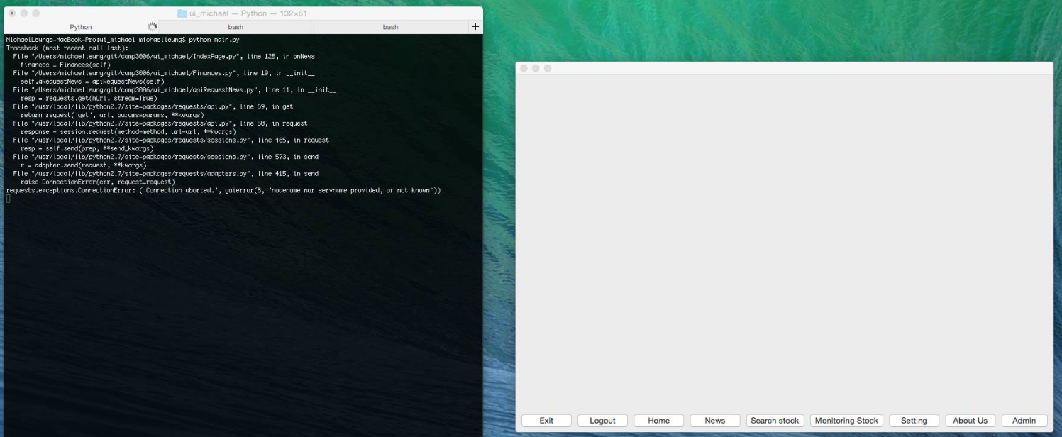

## Monitoring Request Testing (15208249 LEUNG KAI HIN)

### Flow graph:

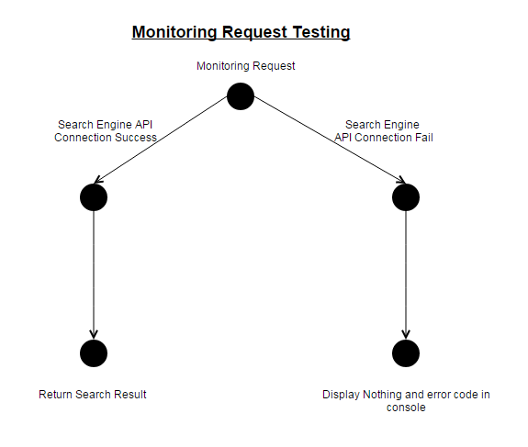

|  |  |
| --- | --- |
| Path 1 | |
| Test Case | Stock Engine API Connection Success |
| Log | Monitoring Stocks Display as List |

|  |  |
| --- | --- |
| Path 2 | |
| Test Case | Stock Engine API Connection Failed |
| Log | UI Display Nothing & Error Code Occurs in Console |

### stock engine api connection success

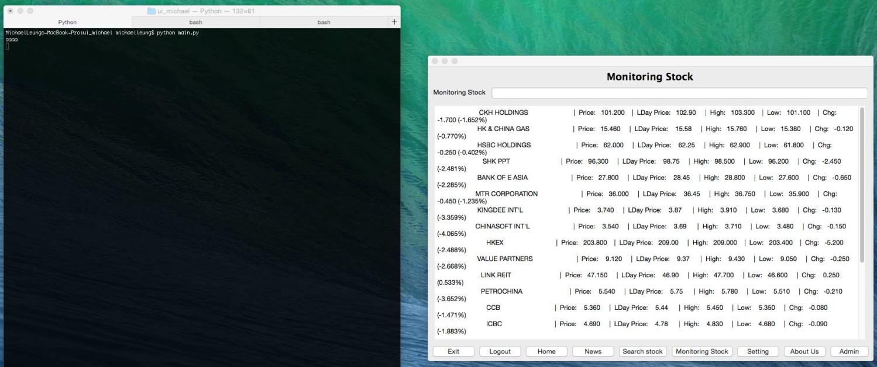

### stock engine api connection failed

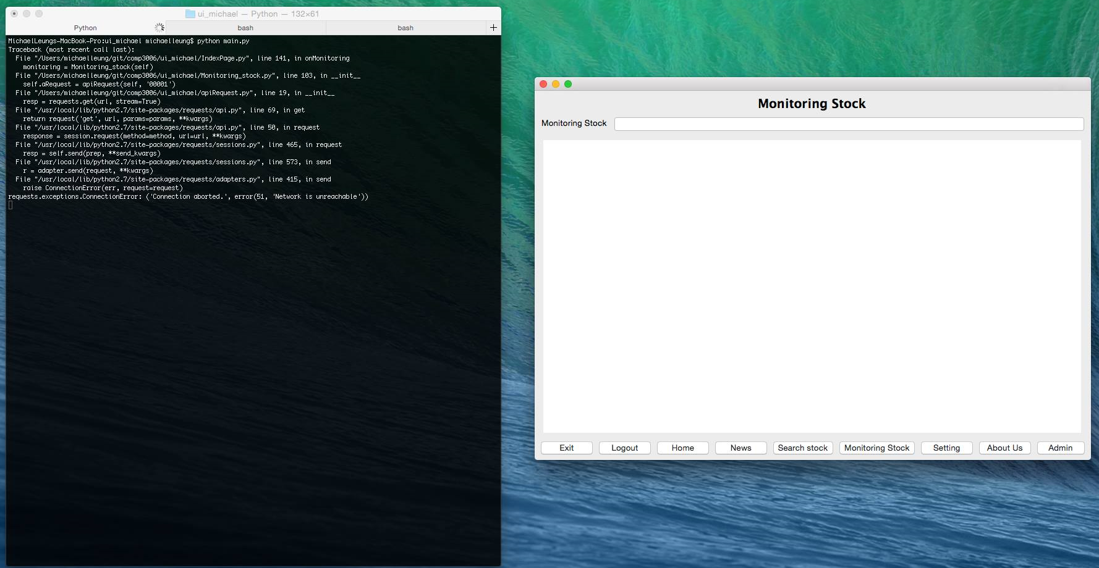

## Frame switch (YEUNG MAN KIT 13207296)

Code:

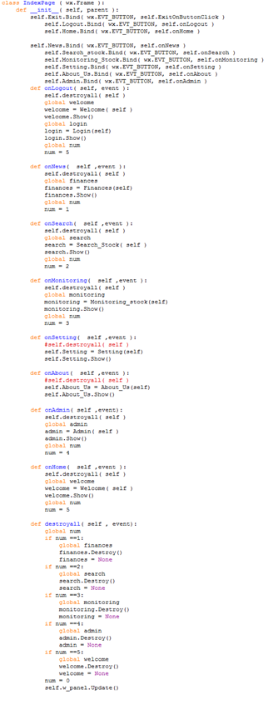

By the above code, we can see that the program is changing the frame through destroyall( self , event) this function to change the frame.

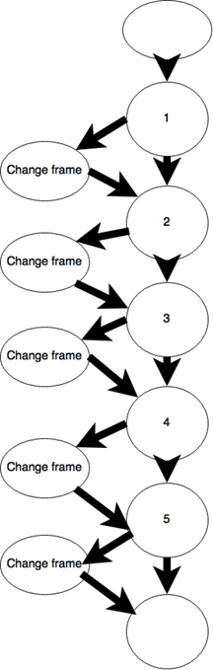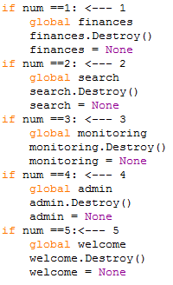

## Change_PW_ctrl Test (Chan Wing Sum 13205633)

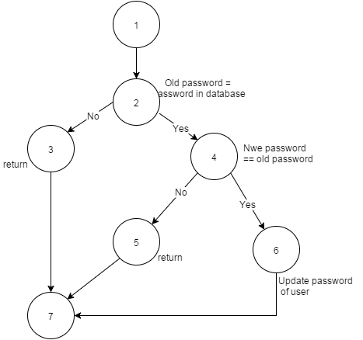

|  |
| --- |
| Possible path: |
| 1,2,3,7 |
| 1,2,4,5,7 |
| 1,2,6,7 |

|  |  |  |  |
| --- | --- | --- | --- |
| **Test case Id** | **Test case Description** | **Expected Result** | **Actual Result** |
| 1 | Precondition: Run Setting  Old password = “1234e6”  Enter:  Old password: “1234e6”  New password: “234567”  Confirm password: “234567”  Button: “Save” | Password change successfully | PASS |
| 2 | Precondition: Run Setting  Old password = “1234e6”  Enter:  Old password: “1234e6”  New password: “234567”  Confirm password: “345678”  Button: “Save” | Password cannot be change, Now password and confirm password must be match. | PASS |
| 3 | Precondition: Run Setting  Old password = “123456”  Enter:  Old password: “234567”  New password: “234567”  Confirm password: “234567”  Button: “Save” | Password cannot be change, Old password must be valid. | PASS |